**Cloud Assignment**

N Rabindra Patra

Block Diagram(Lucid Chart): HA cluster

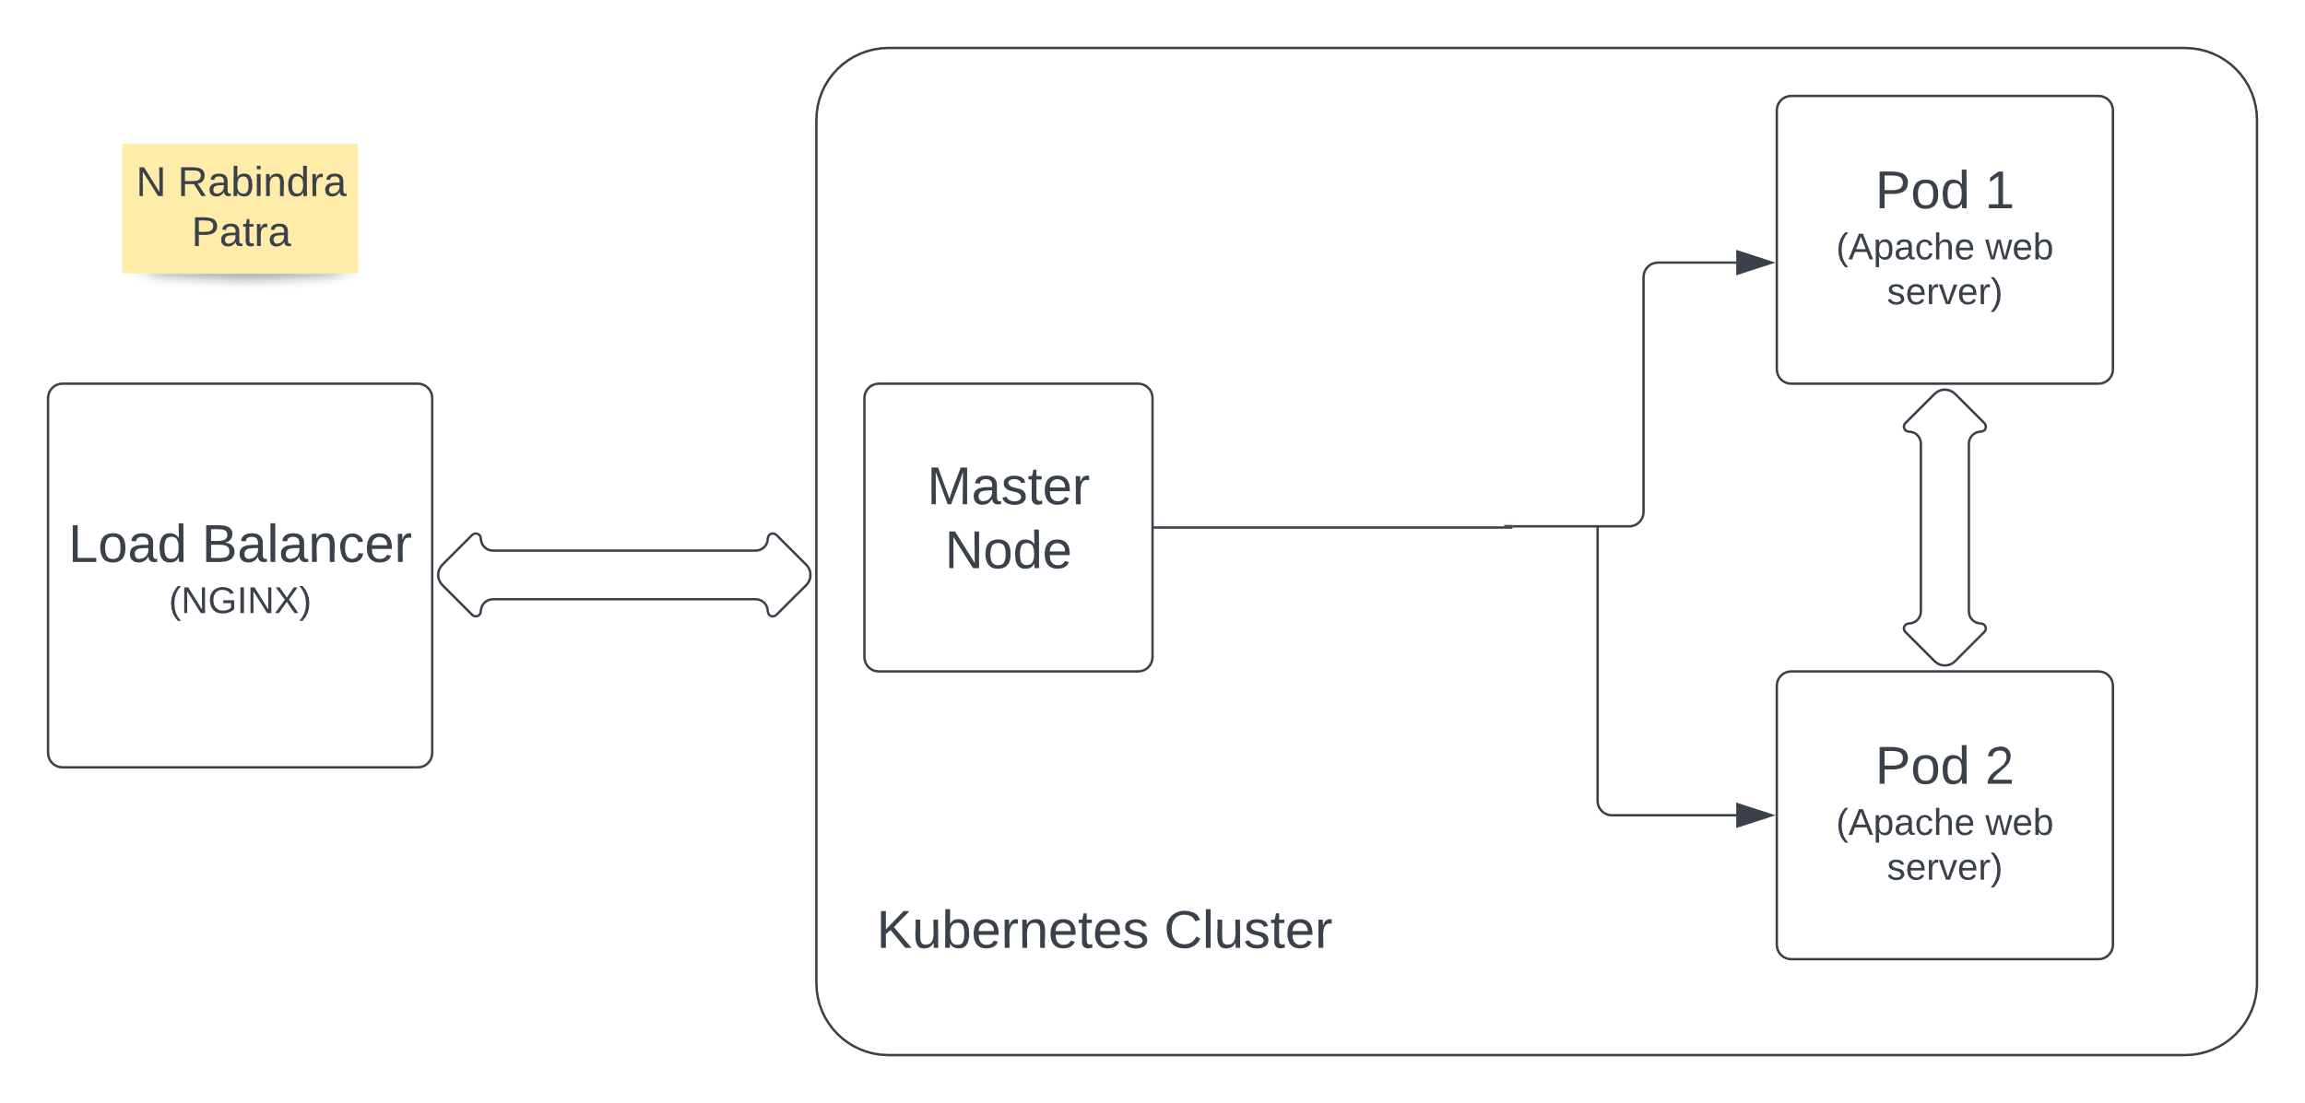

WRITHING THE DEPLOYMENT CONFIGURATION YML FILE:

For this I am writing two YAML files

1. Deployment (nginx-deployment.yaml)
2. Services (nginx-service.yaml)

Deployment (nginx-deployment.yaml):

YAML CODE:

apiVersion: apps/v1

kind: Deployment

metadata:

  name: nginx

  labels:

    app: nginx

spec:

  replicas: 2

  selector:

    matchLabels:

      app: nginx

  template:

    metadata:

      labels:

        app: nginx

    spec:

      containers:

      - name: nginx

        image: nginx

        ports:

        - containerPort: 80

In this I have created two pods (replicas)

Services (nginx-service.yaml):

YAML CODE:

apiVersion: v1

kind: Service

metadata:

  name: ngnix-service

spec:

  selector:

    app: nginx

  type: NodePort

  ports:

  - protocol: TCP

    port: 80

    targetPort: 80

**command:** kubectl apply -f nginx-deployment.yaml

**command:** kubectl get deployment webserver

**command:** kubectl get service webserver

**command:** kubectl get pods

As I am trying to run this command it shows me error and I am working on that errors.

* Using Load Balancer at the entry point, the incoming traffic is distributed among multiple

Kubernetes clusters.

* Kubernetes cluster is a group of nodes that run containerized applications and it also

provides container orchestration.

* A simple Kubernetes cluster contains a Master Node and multiple Worker Nodes.
* Master Node is responsible for managing Kubernetes processing and other Worker Nodes

present in the cluster.

* Worker Node is responsible for executing the containers and applications in the cluster. A

Pod always runs in the worker node.

* A Pod is the smallest deployable unit in Kubernetes. It is basically a Kubernetes wrapper

around the container. Each Pod can contain one or multiple containers depending on use case.

* Here, there are two instances of Apache Web Server running in two different Pods.
* Kubernetes provides High Availability of application by scaling the number of replicas of

Pods. Also, if any failure occurs in any of the Pods, then another Pod takes over.

Note: Till now I have done this much only. After returning to the office on 3rd march I will be continuing this task, currently I am in my college to attend my exams.